**Relational Schema and Normalization:**

**ER-Diagram:**

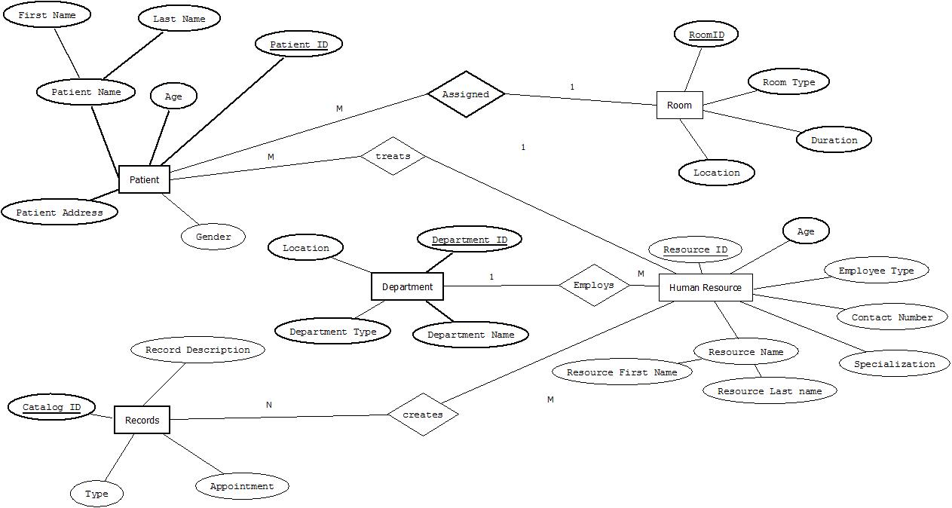

**CONVERSION OF ENTITY DIAGRAM TO RELATIONAL MODEL:**

The conversion from ERD to relational model is shown in the below steps:

**Step 1: Convert Strong entity types to Relational model**

Patient (PatientID,First_Name,Last_Name,Age,Patient_Address,Gender)

Department (DepartmentID,Department_Name,Department_Type,Location)

HumanResource(Resource_ID,Resource_FirstName,Resource_LastName,Age,Employee_Type,ContactNumber,Specialization)

Records (Catalog_ID,Record_Description,Type,Appointment,Type)

Room(RoomID,Room_Type,Duration,Location)

**Step 2: Convert Weak entity types to Relational model**

Not Applicable

**Step 3: Convert Subclass and Union entity types to Relational model**

Not Applicable

**Step 4: Convert 1:1 Binary Relationships to Relational model**

Not applicable

**Step 5: Convert 1:N Binary Relationships to Relational model**

Patient (PatientID,First_Name,Last_Name,Age,Patient_Address,Gender,ResourceID)

Department (DepartmentID,Department_Name,Department_Type,Location)

HumanResource(Resource_ID,Resource_FirstName,Resource_LastName,Age,Employee_Type,ContactNumber,Specialization,DepartmentID)

Records(Catalog_ID,Record_Description,Type,Appointment,Type)

Room(RoomID,Room_Type,Duration,Location,PatientID)

**Step 6: Convert M:N Binary Relationships to Relational model**

Patient (PatientID,First_Name,Last_Name,Age,Patient_Address,Gender,ResourceID)

Department (DepartmentID,Department_Name,Department_Type,Location)

HumanResource(Resource_ID,Resource_FirstName,Resource_LastName,Age,Employee_Type,ContactNumber,Specialization,DepartmentID)

Records(Catalog_ID,Record_Description,Type,Appointment,Type)

Room(RoomID,Room_Type,Duration,Location,PatientID)

Human_Records(ResourceID,CatalogID)

**Step 7: Convert Trinary and N-ary Relationships to Relational model**

Not Applicable

**Step 8: Convert Multivalued Attributes to Relational model**

Not Applicable

**Final Schema:**

Patient (PatientID,First_Name,Last_Name,Age,Patient_Address,Gender,ResourceID)

Department (DepartmentID,Department_Name,Department_Type,Location)

HumanResource(Resource_ID,Resource_FirstName,Resource_LastName,Age,Employee_Type,ContactNumber,Specialization,DepartmentID)

Records(Catalog_ID,Record_Description,Type,Appointment)

Room(RoomID,Room_Type,Duration,Location,PatientID)

Human_Records(ResourceID,CatalogID)